MONGODB TASK 1

MONGODB

- MongoDB is a popular, open-source NoSQL database management system known for its flexibility, scalability, and ease of use.
- It is designed to handle large volumes of unstructured or semi-structured data, making it well-suited for a wide range of applications
Key Concepts:
· Document- Oriented - it stores data in JSON-like documents
· Collections- data into collections (tables)
· NoSQL- (Not Only SQL) database ,No fixed schemas/structure
· Scalability- handling large datasets.(load balance)

QUESTIONS WITH ANSWERS

- Find all the information about each products
db.product.find();
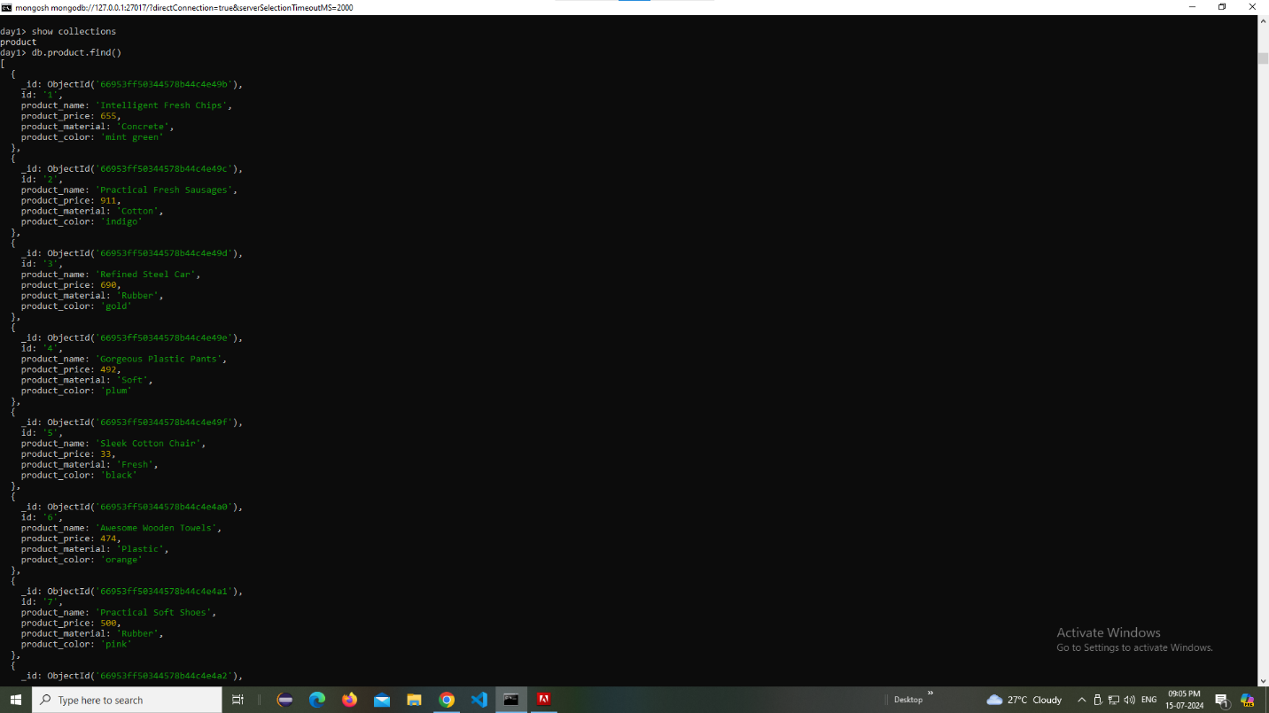

- Find the product price which are between 400 to 800
db.product.find({product_price:{$gt:400, $lt:800}});

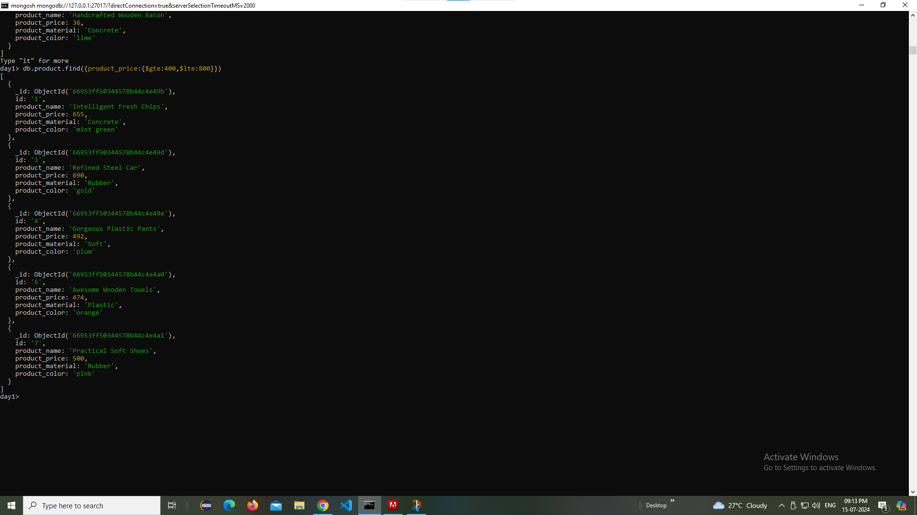

- Find the product price which are not between 400 to 600
db.product.find({product_price:{$not:{$gte:400, $lte:600}}});
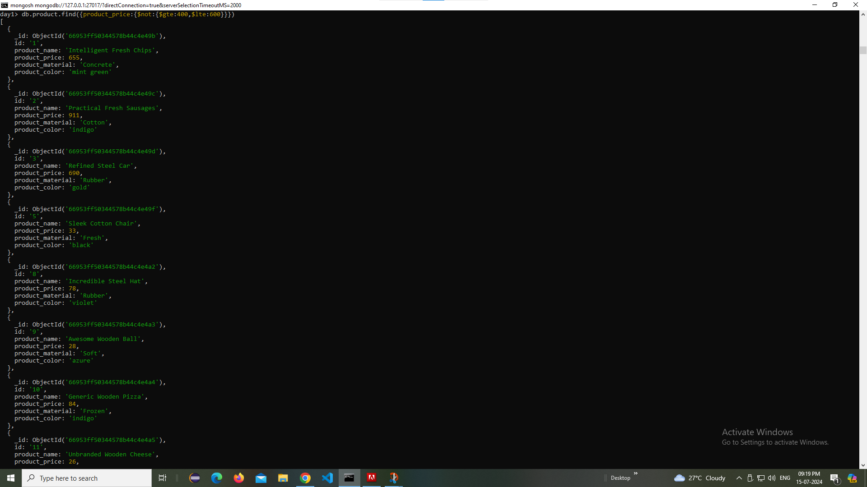
4) List the four product which are greater than 500 in price
db.product.find({product_price:{$gte:500}}).limit(4)

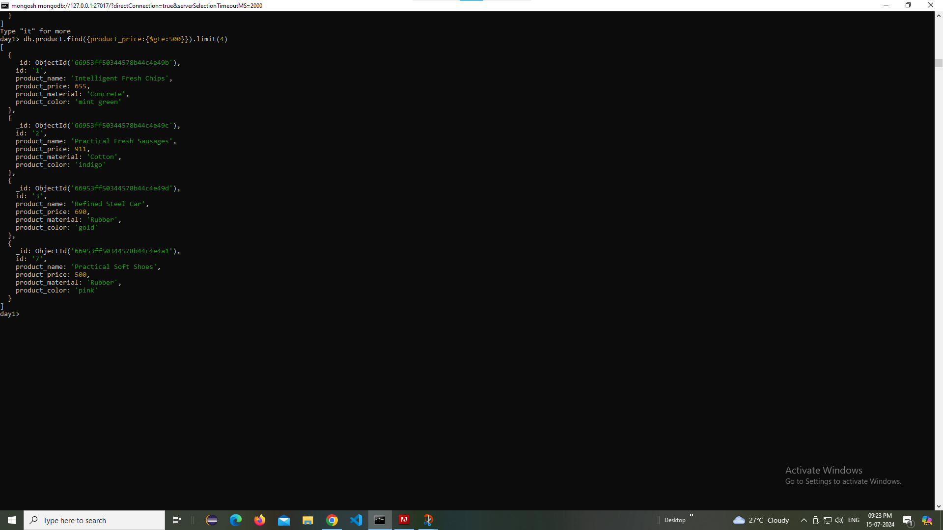

5) Find the product name and product material of each products
db.product.find({},{product_name: 1, product_material:1});
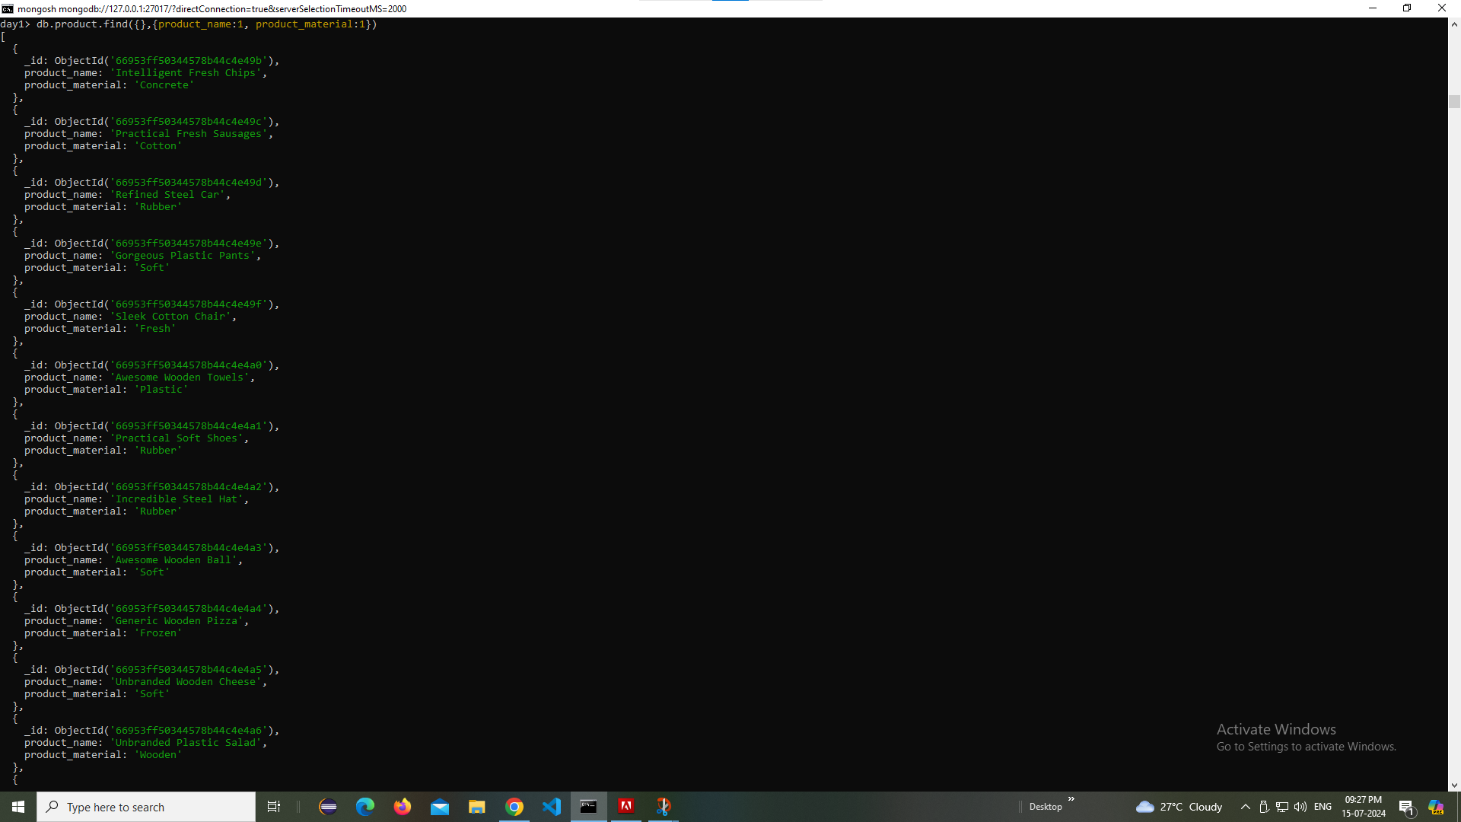

6) Find the product with a row id of 10
db.product.find(id:”10”);

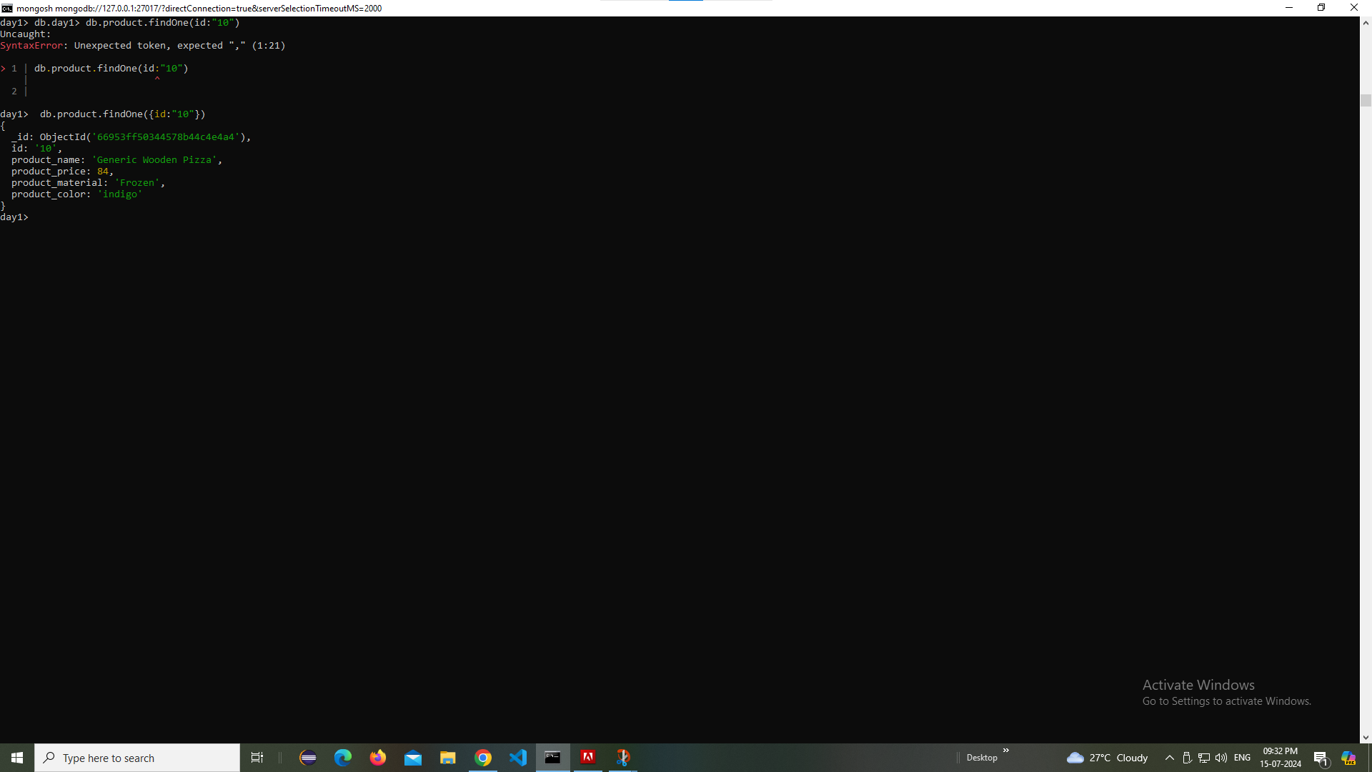

7) Find only the product name and product material
db.product.find({},{product_name: 1, product_material:1}).map(doc=>[doc.product_name,doc.product_material]);

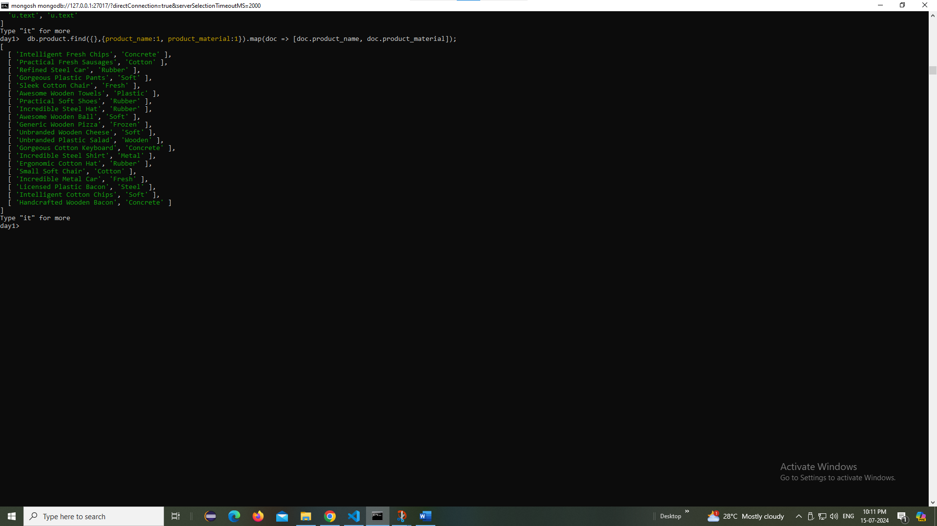

8) Find all products which contain the value of soft in product material
db.product.find({product_material: ‘Soft’})
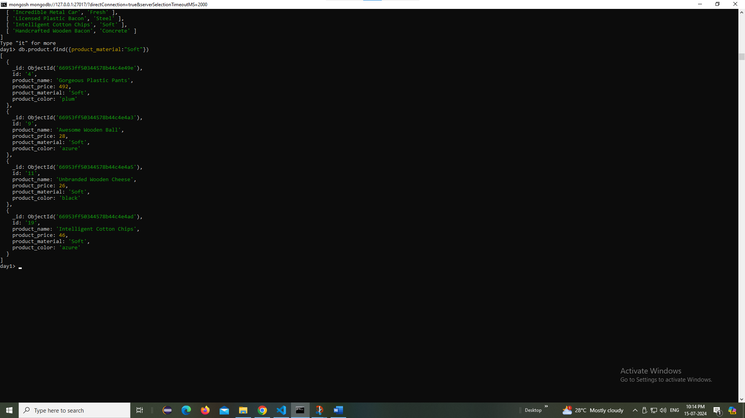
9) Find products which contain product color indigo and product price 492.00
db.product.find({$or:[{product_color:'indigo'},{product_price: 492}]});

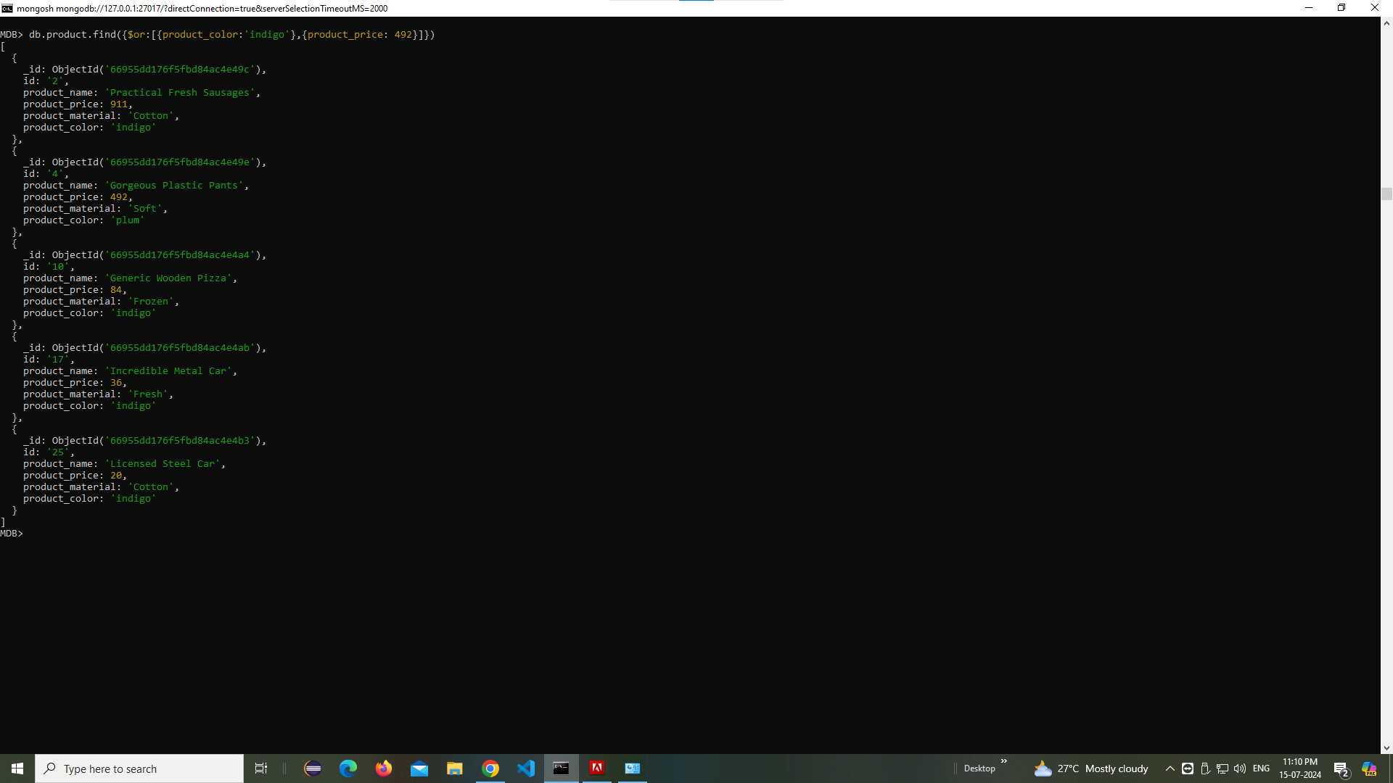

10) Delete the products which product price value are 28
db.product.deleteOne({product_price:28});
